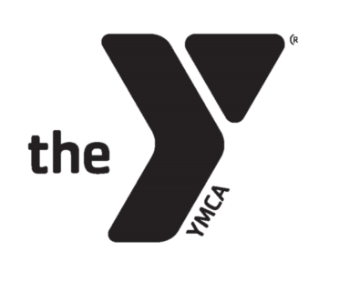

**YMCA CAMP TIPPECANOE**

Permission to Retreat and Liability Release

**PERMISSION TO TREAT:** In case of medical illness or injury, I hereby give permission to YMCA of Central Stark County / YMCA Camp Tippecanoe personnel to provide routine health care, first aid, medication or treatment as determined by medical personnel. IN CASE OF MEDICAL EMERGENCY or medical care beyond the scope of camp facilities, I understand that every effort will be made to notify my listed contacts. I authorize the YMCA of Central Stark County personnel to act on my behalf and secure emergency medical treatment and grant permission to the attending physician to secure proper treatment for the named camper.

**Liability Release:** I understand my child may be involved in activities at camp that include but are not limited to horseback riding, challenge course, boating, target sports, aquatics, and outdoor activities. I acknowledge that my child may decline to participate in any activity. Any participation will be voluntary. I, the undersigned parent/guardian, do hereby accept all responsibility for, and assume the risk of any injury or damage to my person or dependent children which might arise directly or indirectly as a result of, and/or participation in a YMCA of Central Stark County program. I hereby expressly release, discharge and hold harmless from any liability whatsoever the YMCA, the various branches and subdivisions expressly including but not limited to the Board of Trustees of the YMCA, except for injuries caused intentionally, or by willful misconduct. I certify that I am familiar with the contents of the release, that I have read and understand the same, and that it is my intention by signing this release that the same be binding not only on me, but my heirs, administrators, executors, successors, and assigns. The YMCA of Central Stark County / YMCA Camp Tippecanoe is not responsible for misplaced, stolen, or damaged items.

**Photo / Video release:** I authorize the YMCA to take and use any photographs, comments, and videos of myself and / or my child for promotional purposes.

__________________________________________________________ _____________________

Signature: Date

__________________________________________ ______________________________________

Parent/Guardian Name, if under 18: Child Name

__________________________________________ ______________________________________

Parent / Guardian Primary Email Address Primary’s Phone Number

**Emergency Contract (Minimum of 1)**

__________________________________________ ______________________________________

Emergency Contact name Phone Number

__________________________________________ ______________________________________

Emergency Contact name Phone Number

__________________________________________ ______________________________________

Emergency Contact name Phone Number